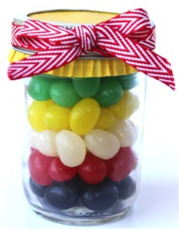
Gospel Ideas
Jelly Beans in a Mason Jar with Poem
www.thefrugalgirls.com/2014/03/a-jelly-bean-prayer-gift-in-a-jar.html
Wordless Book Cross Necklace:
http://www.123homeschool4me.com/2015/07/wordless-book-lesson.html
All Kinds of examples for the Wordless book:
http://www.hsprintables.com/wordlessbook.html
Gospel Cookies in a Mason Jars, Wordless Book Lapbook: www.teaching4joy.blogspot.com/2011_04_01_archive.html
Beanbags made in the wordless book colors, use them for a variety of activities
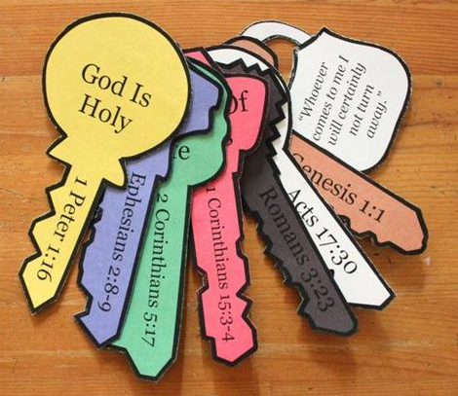
Tasty Treat for teaching the Wordless book:
www.stevencribbs.com/vbs-day-4/
Preschooler Age activity for Wordless Book:
www.hayesfamily.co.za/blog/2009/04/wordless-book/
Keys to Salvation:
www.craftingthewordofgod.com/2015/01/20/keys-of-salvation/
Gospel Poster:
www.centrikid.com/2013/02/04/gospel-with-kids-poster/#.VediofSrEg9
One Verse Evangelism Activity:
www.navigators.org/Tools/Evangelism%20Resources/Tools/One-Verse%20Evangelism-%20How%20to%20Share%20Christ-s%20Love%20C
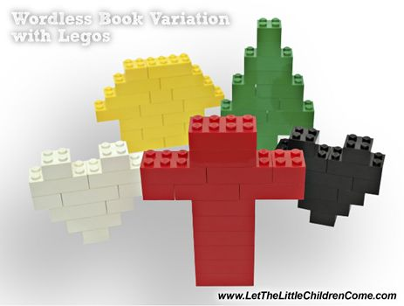
Wordless book Layered Cake: One layer in each color

Using Legos to tell the Gospel Story:
www.letthelittlechildrencome.com/child-evangelism-resources/Wordless-Book-Variation-Lego-Bricks/26

