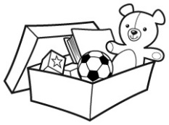
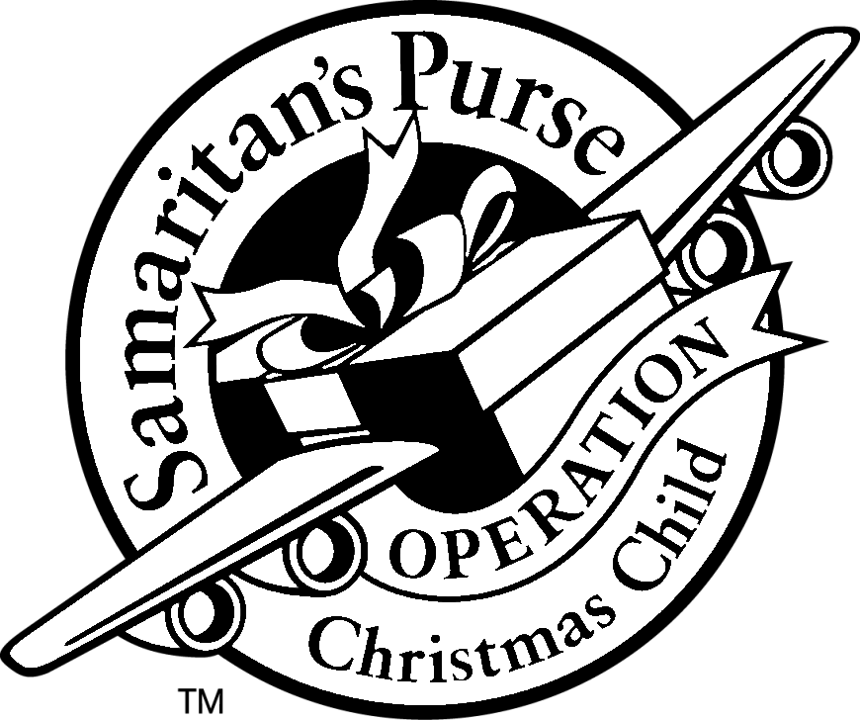101 Shoebox Ideas

- “All About Me” Page
- Balloons
- Balls: Tennis balls, bouncy balls, Whiffle balls
- Bandanas
- Bar Soap
- Barbie Type Dolls
- Barrettes
- Bean bags
- Beanie Babies
- Brushes
- Cars/Trucks
- Colored pencils
- Coloring books
- Coloring Markers
- Combs
- Crafting kits
- Crayons
- Doll
- Doll Clothes and Blankets
- Drawstring bag
- Drinking Cups
- Duct Tape
- Eating Utensils
- Nail Files
- Erasers
- Fabric Squares
- Finger puppets
- First Aid kits (with NO medicine)
- Fishing line/Fish hooks (packaged)
- Flashlights
- Flip flops
- Games
- Glue sticks
- Hacky sack ball
- Hair ribbons
- Hammers
- Hand mirror (unbreakable)
- Hand wipes
- Handheld Etch-A-Sketch
- Handmade Photo Books
- Happy Meal toys
- Harmonicas
- Hats
- Head Bands
- Inflatable balls
- Jewelry
- Jigsaw puzzles
- Jump ropes
- Keychains
- Legos
- Lip balm
- Make-up (no liquid varieties)
- Manicure kits
- Miniature checkers Game
- Multi-colored Sharpies
- Musical Instruments
- Nail clippers
- Nails (boxed or bagged)
- Notepads
- Paddle balls
- Pencil case
- Pencil sharpeners
- Pencils
- Pens
- Personal letter
- Photo of You
- Picture books
- Ponytail holders
- Post-It Notes
- Purses
- Ribbons
- Rulers
- Safety scissors
- Scarves
- Scotch Tape
- Screwdrivers
- Screws (boxed or bagged)
- Sewing Kits
- Shoelaces
- Shoes
- Silly Putty
- Slinky
- Small flannel throw
- Small Plush animals
- Small pots/pans with spatula
- Soccer ball with pump
- Socks
- Stickers
- Sunglasses
- Tape measures
- Teddy bears
- Tissues packets
- Tool Kits
- Toothbrush
- Toy binoculars
- Toys
- Travel sewing kits
- T-shirts
- Wallets
- Work Gloves
- Yoyos

